SUMMER INTERNSHIP REPORT

Exploring Cloud Infrastructure and LLMs  
Using Microsoft Azure and GCP

**Submitted by:**  
Antara Srivastava  
Final Year B.Tech CSE,   
School of Computer Science & Engineering, Bennett University,   
Greater Noida, Uttar Pradesh, India

**Internship Duration:**  
June 2025 – July 2025

**Under the Mentorship of:**  
Dr. Ajay Srivastava  
Practice Head- Geospatial Solutions, HCLTech  
[Ajay.Srivastava@hcltech.com](mailto:Ajay.Srivastava@hcltech.com)  
[www.hcltech.com](http://www.hcltech.com)

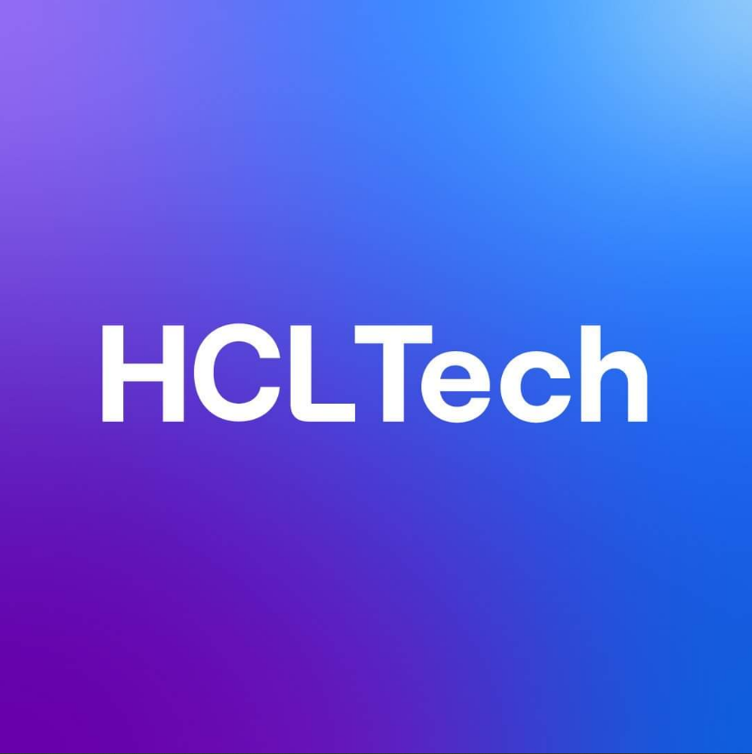

**Date of Submission:**  
4th August 2025

# Acknowledgements

I would like to express my sincere gratitude to **Dr. Ajay Srivastava**, Associate General Manager at HCLTech, for guiding me throughout this internship. His mentorship was instrumental not only in shaping the technical direction of my work but also in helping me approach real-world problems with structured thinking and curiosity. I learned more in these two months than I often do in a full semester of coursework, and that is a testament to how generously he shared his time, insights, and experience.

I also appreciate the support from platforms like **Microsoft Azure**, **Google Cloud Platform**, and **Coursera**. Their services and open documentation made it easier to experiment independently, troubleshoot roadblocks, and gradually move toward more complex use cases. Learning through their ecosystems gave me confidence in understanding tools that are widely used in modern industry.

I am equally thankful to my family for encouraging me to pursue an internship that was less traditional in format but richer in learning. Lastly, I’m grateful for the opportunity to combine curiosity with practice, and I hope this report captures a part of that journey.

Antara Srivastava  
  
04-08-2025  
Place: Noida

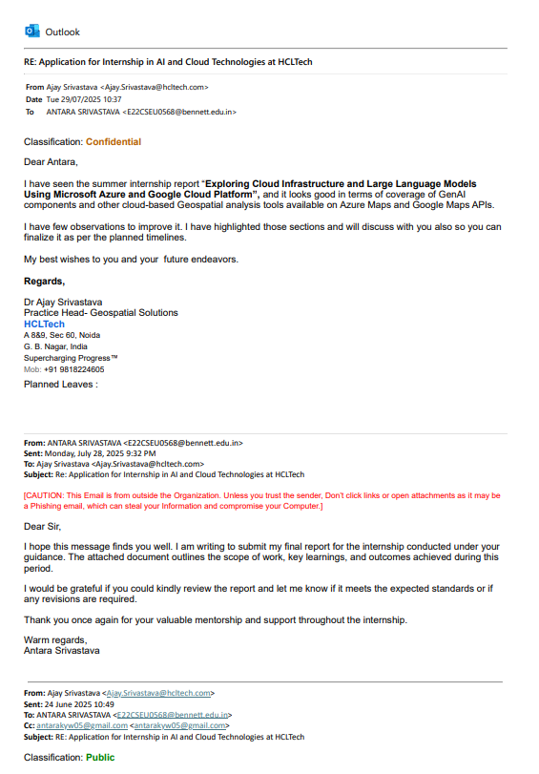

# Executive Summary

This internship was designed as a self-driven learning experience focused on real-world cloud technologies and AI infrastructure. The intention was not just to complete a set of exercises, but to explore actual tools, environments, and APIs that developers and data scientists work with daily in industry settings.

Under the guidance of a mentor with experience at HCLTech, I approached the internship as a structured yet independent exploration of two key ecosystems - **Microsoft Azure** and **Google Cloud Platform (GCP)**. I worked through technical workflows that mimicked real-world scenarios, such as building mapping and logistics solutions using Azure Maps, and designing and evaluating AI prompts on Google Cloud’s Vertex AI Studio.

On Azure, I concentrated on **Azure Maps**, which offers a powerful suite of geospatial APIs. My work ranged from implementing basic POI (point of interest) search experiences to more advanced routing tasks for logistics, including truck vs car route comparisons and traffic-based adjustments. I also used the weather module and combined it with simulated sensor data using Jupyter notebooks. These projects helped me understand how mapping, geolocation, and weather intelligence can integrate into enterprise applications.

The internship also placed a strong focus on the rising field of **Large Language Models (LLMs)**. I explored tools like **Vertex AI Studio**, **Generative AI Workbench**, and **Gemini 1.5 Pro APIs**. My work here included prompt engineering, running side-by-side model evaluations, analysing outputs for sentiment, and playing with prototype-level ideas for retrieval-augmented generation (RAG). This gave me a clear view of how AI developers approach prompt consistency, model bias, fine-tuning vs prompt-tuning, and the trade-offs between different LLMs.

To support this hands-on learning, I also completed the Coursera course: **LLMOps with Azure**, which added theoretical grounding to the implementation work. It covered the model development lifecycle, integration with APIs, managing evaluation pipelines, and understanding metrics like latency, token usage, and accuracy.

This report documents the experience in detail starting from tools and setup to individual technical exercises and their outcomes. It reflects not only the tools I used, but also the thinking process I developed along the way. This internship helped me become more confident in debugging, researching APIs, designing workflows, and understanding what it means to build production-adjacent systems in cloud and AI environments. **Google Cloud’s Vertex AI**, where I experimented with **prompt engineering**, **model comparison**, **sentiment analysis**, and **RAG workflows** using the **Gemini family of LLMs**.

This report outlines the technical work done, the tools used, and the outcomes achieved through hands-on exploration. It reflects both the depth and breadth of my learning journey over one month.

Table of Contents

Acknowledgements 2

Executive Summary 4

1. Introduction 10

2. Organization Profile 11

3. Technologies & Tools Used 11

4. Prompt Engineering Techniques 12

4.1 Single Prompt Techniques 12

4.2 Multiple Prompt Techniques 13

4.3 LLM + External Tools Integration 13

5. Vertex AI 15

5.1 Generative AI Models and Tools 15

5.2 Unified Machine Learning Workflow 16

5.3. Built-in MLOps Tooling 16

5.4. AutoML Capabilities 16

5.5. Scalable and Managed Infrastructure 16

5.6. Agent Builder 17

5.7. Model Garden 17

6. AI/ML Workflow Architecture 18

6.1 Data Ingestion Layer 18

6.2 API and Middleware Layer 18

6.3 AI Model Layer 18

6.4 Evaluation & Monitoring Layer 19

6.5 Application/UX Layer 19

7. Microsoft Azure Projects 20

7.1 Interactive Map Search 20

7.2 Map Routing Between Cities 20

7.3 Truck vs Car Route Simulation 21

7.4 Custom Store Locator 22

7.5 Sensor + Weather Data Visualization 23

8. Google Cloud Platform Projects 25

8.1 Exploring Vertex AI Studio 25

8.2 Prompt Iteration and System Instructions 26

8.3 Model Evaluation Using Vertex AI 27

8.4 Tuning Methods 28

9. Coursera Learning 29

9.1 Operationalizing LLMOps with Azure 29

9.2 Machine Learning Operations with Vertex AI: Model Evaluation 30

10. Comparative Study: Azure vs GCP vs AWS 33

11. Challenges Faced 34

12. Industry Challenges and Opportunities 35

12.1 Key Industry Challenges 35

12.2 Emerging Opportunities 35

12.3 Latest Trends in AI & Cloud Deployment 35

12.4 Use Cases 36

13. Key Learnings 37

14. Future Scope 37

15. Conclusion 37

16. Appendix 38

Appendix A: Coursera Certifications 38

A.1 – Operationalizing LLMs on Azure 38

A.2 – Machine Learning Operations with Vertex AI: Model Evaluation 38

Appendix B: Code Snippets 39

B.1 – Record Store centre 39

B.2 – Truck Map Route Locations 39

B.3 – Weather Dataset 40

Appendix C: Trail Mail 41

17. Bibliography 43

# Introduction

The adoption of cloud-native platforms and artificial intelligence is redefining how organizations design, deploy, and scale modern software systems. These technologies are no longer supplementary, they are foundational to how intelligent, data-driven applications are built and maintained. Recognizing this shift, I structured my internship to explore the practical and technical nuances of working with cloud AI infrastructure, bridging the gap between academic theory and industry-aligned practices.

This internship was conducted under the mentorship of an experienced professional from HCLTech, with a focus on hands-on, exploratory learning rather than predefined deliverables. The structure allowed for open-ended investigation into cloud tools, API integration, prompt engineering, and large language model (LLM) operations using industry-leading platforms: **Microsoft Azure** and **Google Cloud Platform (GCP)**.

On the Azure side, I worked primarily with **Azure Maps**, gaining exposure to geospatial APIs, data visualization, and location-based routing systems. In parallel, I explored **Vertex AI** on GCP (Google’s managed platform) for developing and scaling ML models. My key focus areas on GCP included:

* Designing and iterating on prompt formats
* Comparing output behaviour across Gemini models
* Using structured output techniques such as JSON for system integration
* Evaluating models via Vertex AI’s built-in metrics and side-by-side comparisons

Particularly, I explored various prompt engineering strategies, such as:

* Freeform prompts for quick interaction
* Explanation-based prompts for interpretability
* JSON-structured prompts for automated systems

I also worked with the **Vertex AI Model Garden**, which allowed me to experiment with Google-built and third-party models in a controlled environment. This component proved instrumental in identifying model strengths for tasks such as summarization, classification, and reasoning.

To contextualize these tools in real-world settings, I studied industry-aligned use cases including:

* Predictive maintenance through sensor data
* Work order prioritization using AI-generated risk scores
* Voice-enabled technician assistants powered by LLMs
* Real-time performance dashboards for operational monitoring

Lastly, I reviewed and diagrammed general-purpose AI/ML cloud architectures, focusing on five layers: ingestion, middleware/API management, model execution, evaluation, and user-facing visualization. This modular approach was reflected in both Azure’s and GCP’s service structures and helped ground my learning in platform-agnostic design principles.

This report summarizes the learning outcomes, tools explored, and industry perspectives gained through this internship. It is structured to cover both the theoretical frameworks and the practical implementations, reflecting how large-scale AI and cloud platforms are used in real-world engineering contexts.

# Organization Profile

This internship was conducted as a mentorship-driven learning experience under **Mr. Ajay Srivastava**, Associate General Manager at **HCLTech**. While the internship was not officially affiliated with HCL, the structure, tools, and discussions were strongly inspired by real-world practices and projects that are part of HCL’s enterprise services.

The environment was set up to simulate the kind of technical exposure a junior engineer might receive on actual client or internal projects. I was guided to think critically, work independently, and document my progress in a manner that reflects how development and experimentation happens in the cloud and AI domains.

# Technologies & Tools Used

**Microsoft Azure**:

* Azure Maps REST APIs
* Map Control SDK (JavaScript)
* Weather Services

**Google Cloud Platform (GCP)**:

* Vertex AI Studio
* Gemini 2.5 Pro, Gemini 2.0 APIs
* Prompt Engineering and Comparison
* Sentiment Analysis Tasks

**Additional Tools**:

* Coursera Platform (LLMOps with Azure Course)
* Visual Studio Code / Jupyter Lab
* HTML, JavaScript, Python

# Prompt Engineering Techniques

Prompt engineering has emerged as a critical discipline in the AI development lifecycle, especially with the rise of large language models (LLMs). It involves crafting and structuring inputs to guide the model toward producing more accurate, relevant, or structured outputs. During my internship, I explored a wide range of prompt engineering strategies — from basic zero-shot formats to multi-stage reasoning workflows — to understand how prompt design impacts model behaviour.

Prompting techniques can be categorized based on their complexity, structure, and integration with external tools. Below is an overview of major categories and representative techniques:

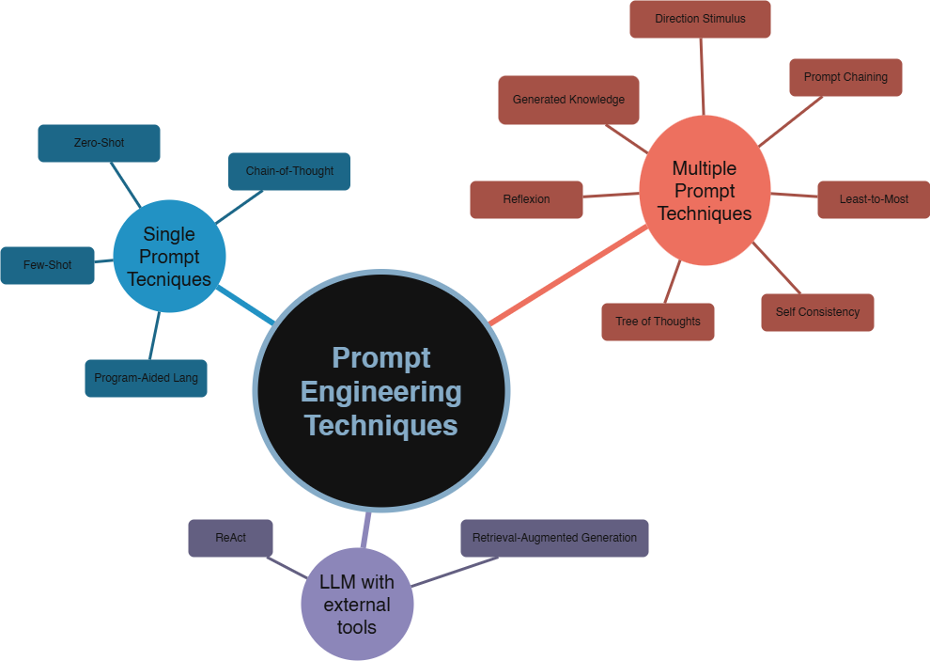

**Fig 1: Prompt Engineering Techniques**

## 4.1 Single Prompt Techniques

These approaches focus on designing one-time prompts that elicit responses without requiring feedback loops or external memory.

1. **Zero-Shot Prompting**: The simplest form, where the model is given a task directly without examples.
2. **Few-Shot Prompting**: Provides a few examples in the prompt to help the model understand the task.
3. **Chain-of-Thought Prompting**: Asks the model to think step-by-step and show its reasoning.
4. **Program-Aided Language (PAL)**: Asks the model to write code as its reasoning path, enhancing reliability for logic-based problems.

## 4.2 Multiple Prompt Techniques

These methods involve sequential or parallel prompts to improve consistency, performance, or coverage. It is based on different strategies of combining prompts of one or a few of models:

* **Voting.** The idea is to apply voting to get the correct answer. Techniques: Self-Consistency.
* **Divide and conquer.** This group of prompts is based on dividing a complicated task into a few prompts. Techniques: Directional Stimulus, Generate Knowledge, Prompt Chaining, Chain-of-Table and Least-to-Most prompting.
* **Self-evaluation**. The approach suggests including into a framework a step of checking whether the output meets instructions. Techniques: Reflexion, Tree-of-Thoughts.

Below is an overview of the main techniques:

1. **Prompt Chaining**: Breaks a complex problem into smaller sub-prompts and combines outputs.
2. **Least-to-Most Prompting**: Begins with simpler sub-tasks before tackling the full problem.
3. **Self-Consistency (SC)**: Runs the same prompt multiple times and aggregates results (e.g., via voting).
4. **Tree-of-Thoughts (ToT)**: Explores multiple solution branches simultaneously and selects the best path.
5. **Generated Knowledge (GK)**: First prompts the model to generate relevant background knowledge, then uses it in the final prompt.
6. **Directional Stimulus Prompting (DSP)**: Provides hints to bias the model toward useful outputs.
7. **Reflexion**: Introduces a feedback loop where the model critiques and reattempts its own outputs.

## 4.3 LLM + External Tools Integration

These techniques incorporate outside systems to supplement the model’s responses.

1. **Retrieval-Augmented Generation (RAG)**: Pulls factual data from an external database (like a document store) and feeds it into the prompt.

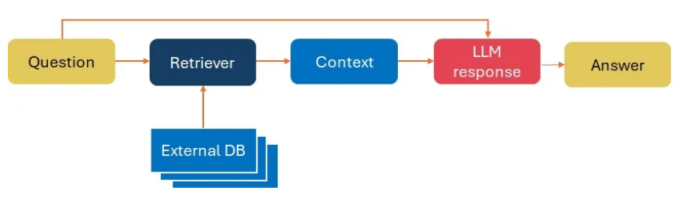

**Fig 2: RAG Workflow**

1. **ReAct**: Uses external tools like calculators, search engines, or APIs to perform tasks the model can’t do natively.

The effectiveness of an LLM often depends more on how it’s prompted than the model itself. During hands-on testing on Vertex AI with Gemini models, I found that:

* Chain-of-thought prompts were significantly better for complex reasoning tasks.
* JSON-constrained outputs helped automate evaluation pipelines.
* Generated knowledge helped avoid hallucinations in zero-shot tasks.

This spectrum of techniques forms the basis for building reliable, accurate, and context-aware AI systems.

# 5. Vertex AI

Vertex AI is a centralized environment on Google Cloud Platform that enables users to discover, experiment with, and deploy pre-trained machine learning models. It serves as a curated marketplace of both first-party and third-party models.

From pre-trained models to MLOps tools, Vertex AI brings together everything you need to build, scale, and optimize ML models, all in one place. It’s more than just a model training interface —it’s an end-to-end ecosystem that supports every phase of the ML lifecycle, from experimentation to production-level operations. Below are its core features:

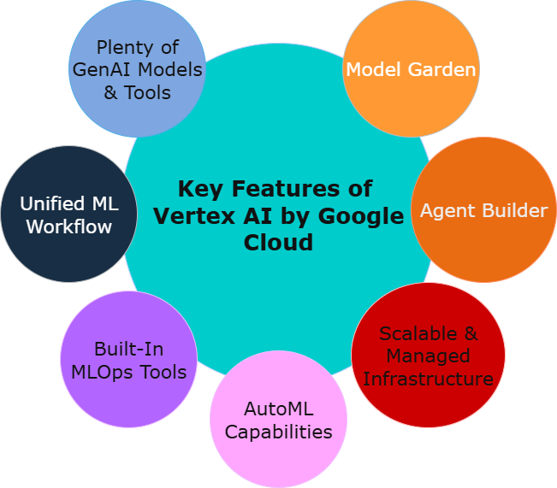

**Fig 3: Vertex AI Key Features**

## 5.1 Generative AI Models and Tools

Vertex AI offers seamless access to pre-trained large language models, including Google’s Gemini Pro and Gemini Flash, as well as PaLM and other third-party models. These models are fine-tuned for a variety of tasks such as:

* Text summarization
* Question answering
* Translation
* Sentiment analysis
* Code generation

Developers can either use them as-is or customize them further through prompt tuning or supervised fine-tuning.

## 5.2 Unified Machine Learning Workflow

Vertex AI unifies the entire ML lifecycle into a single managed workflow, encompassing:

* Data labelling and preparation
* Training using AutoML or custom containers
* Model evaluation and tuning
* Deployment via endpoints
* Post-deployment monitoring and model retraining

This streamlined workflow ensures that all ML activities stay version-controlled, reproducible, and production-ready.

## 5.3. Built-in MLOps Tooling

A major strength of Vertex AI lies in its native MLOps capabilities, which enable teams to:

* Automate training pipelines using Vertex Pipelines
* Track experiments and metadata with ML Metadata
* Perform continuous evaluation and drift detection
* Manage models using Model Registry

This reduces the operational burden of maintaining AI systems at scale and aligns with CI/CD principles for machine learning**.**

## 5.4. AutoML Capabilities

For users without deep ML expertise, AutoML provides a low-code interface to build high-quality models using:

* Tabular data
* Images
* Text
* Time series

The system handles preprocessing, architecture search, hyperparameter tuning, and model validation automatically, producing models that are ready for deployment or further refinement.

## 5.5. Scalable and Managed Infrastructure

Vertex AI is tightly integrated with GCP’s scalable backend, providing:

* Distributed training on TPUs and GPUs
* Serverless endpoints for real-time inference
* Batch prediction at scale with optimized compute provisioning
* Access to BigQuery, GCS, Pub/Sub and more for seamless data movement

The infrastructure is fully managed, allowing teams to focus on experimentation and deployment without worrying about underlying hardware or scaling constraints.

## 5.6. Agent Builder

With the rise of generative AI applications, Vertex AI also includes tools to help build LLM-powered agents, such as chatbots or assistants. These agents can be:

* Task-specific (e.g., customer support, internal Q&A)
* Trained using documents, FAQs, or structured knowledge bases
* Integrated using natural language interfaces or programmatic APIs

This enables enterprises to embed intelligent assistants into their workflows with minimal engineering overhead.

## 5.7. Model Garden

The Model Garden is one of Vertex AI’s most powerful features. It functions as a model discovery and experimentation hub, allowing users to:

* Browse a curated list of Google-built and third-party models
* Filter by use case, task type, model family, or provider
* Test prompts live in the browser using Vertex AI Studio
* Compare outputs from multiple models’ side-by-side
* Deploy models directly to production pipelines (batch or real-time)

The Model Garden bridges the gap between research models and deployable solutions, making it easy for users to select the best-fit model for their application.

# 6. AI/ML Workflow Architecture

Modern AI applications typically follow a modular architecture. The goal is to separate concerns like ingestion, processing, reasoning, and visualization making the system scalable, traceable, and efficient. He following layers are typically involved in a robust AI/ML deployment:

## 6.1 Data Ingestion Layer

This layer is responsible for sourcing and aggregating raw data from a wide variety of sources. These sources may include:

1. **Structured sources:** SQL databases, CRM/ERP systems, cloud data warehouses like BigQuery or Snowflake.
2. **Unstructured sources:** IoT sensors (e.g., temperature or vibration monitors), satellite or map-based APIs (like Azure Maps), free-text documents, log files, or images.

Think of this as collecting all raw ingredients before cooking – they may come from different vendors and require washing or chopping before use. The data collected here must be normalized, cleaned, and transformed into a format suitable for machine learning pipelines. Ingested data often flows into cloud storage (like Google Cloud Storage or Azure Blob Storage) for further processing.

## 6.2 API and Middleware Layer

This is where business logic is often enforced before hitting the ML model. It’s a sort of digital receptionist that decides what gets in, when, and how. The layer acts as a gatekeeper and messenger between the external world and the internal ML services. It manages:

* Authentication and access control using API keys, Oauth2, or IAM roles.
* Rate-limiting to prevent system overload and ensure fair usage.
* Request routing and preprocessing, sometimes transforming incoming requests into formats expected by the model.

Middleware is typically implemented using API Gateway tools like Apigee (GCP) or Azure API Management, and may include functions such as request validation, schema enforcement, and integration with external systems like ERPs or front-end apps.

## 6.3 AI Model Layer

This is the core inference layer, where trained models live and operate. Depending on the use case, this may include:

* Pre-trained foundation models, such as Gemini or PaLM, hosted on Vertex AI Endpoints.
* Custom models, trained on enterprise-specific data using AutoML or custom training pipelines.
* Support for real-time or batch prediction, depending on the API call frequency.

Each model responds to prediction requests by generating classifications, scores, text completions, or other outputs based on the input data. Example: A request might include “Analyse this review and return sentiment as structured JSON,” which the deployed **Gemini model** will parse and respond to accordingly.

## 6.4 Evaluation & Monitoring Layer

This is where performance is continuously tracked post-deployment. Core responsibilities include:

* **Model evaluation** using precision, recall, F1-score, and AUC metrics.
* **Drift detection** to identify when incoming data differs from training data.
* **Fairness auditing** to ensure unbiased predictions across groups.
* **Feedback loop support** for retraining based on failed or low-confidence predictions.

GCP tools like **Vertex AI Model Evaluation**, **BigQuery**, and **Model Monitoring** are used to generate dashboards and alerts that notify engineers of declining model quality or anomalies in behaviour.

## 6.5 Application/UX Layer

This is the **end-user interface**- the layer where the model’s output becomes actionable. This might include:

* **Interactive dashboards** built with tools like **Looker Studio**, **Streamlit**, or **Power BI**.
* **Mobile or web applications** that make real-time predictions accessible to field teams.
* **APIs consumed by other internal software** for automation (e.g., triggering alerts, generating maintenance orders).

Here, the AI system delivers not just insights, but real-time, interpretable, and impactful decisions to users across departments. The key design goal is to ensure output is clear, relevant, and integrated into the user’s existing workflow.

**Fig 4: AI/ML Workflow**

# 7. Microsoft Azure Projects

During the first phase of my internship, I focused on working with **Azure Maps**, Microsoft’s geospatial platform. The objective was to get familiar with how modern web applications can integrate maps, location data, routing, and external data sources like weather APIs in practical ways. The following sections describe the various exercises I undertook, the tools used, and what each task taught me.

## 7.1 Interactive Map Search

My first hands-on task involved using the **Azure Maps Web SDK** to build an interactive location search experience. The goal was to mimic how modern applications suggest nearby points of interest (POIs). I implemented a simple webpage with a search bar that called the Azure Maps Search service to find record stores. When I hovered over a result, the corresponding pin on the map would animate or pop up with more information, giving users visual feedback.

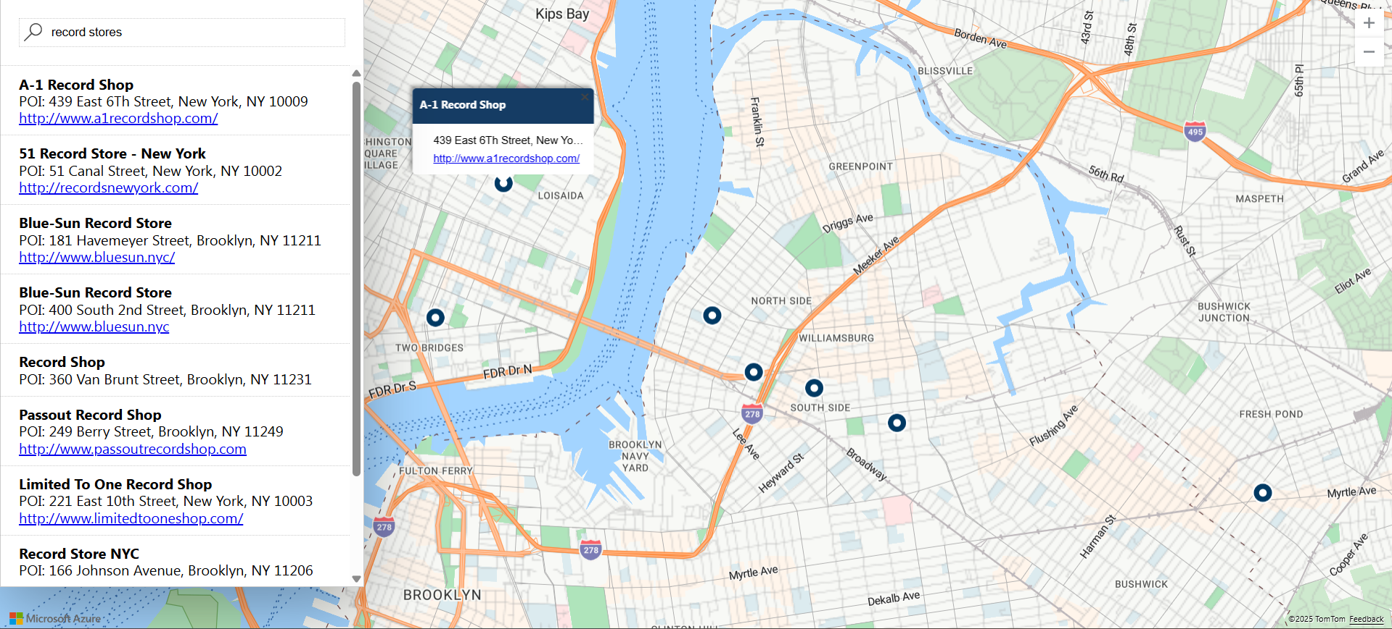

**Fig 5.0: Map showing nearby record stores**

This exercise helped me understand:

* How to make REST API calls to Azure Maps Search endpoint
* How to bind results to UI elements dynamically
* Basic geocoding and reverse geocoding logic

## 7.2 Map Routing Between Cities

The next step was experimenting with **route plotting APIs**. I created a map view that drew a route from Paris (blue mark) to Versailles (red mark). The route line was generated by passing the origin and destination coordinates to the Azure Maps Routing API.

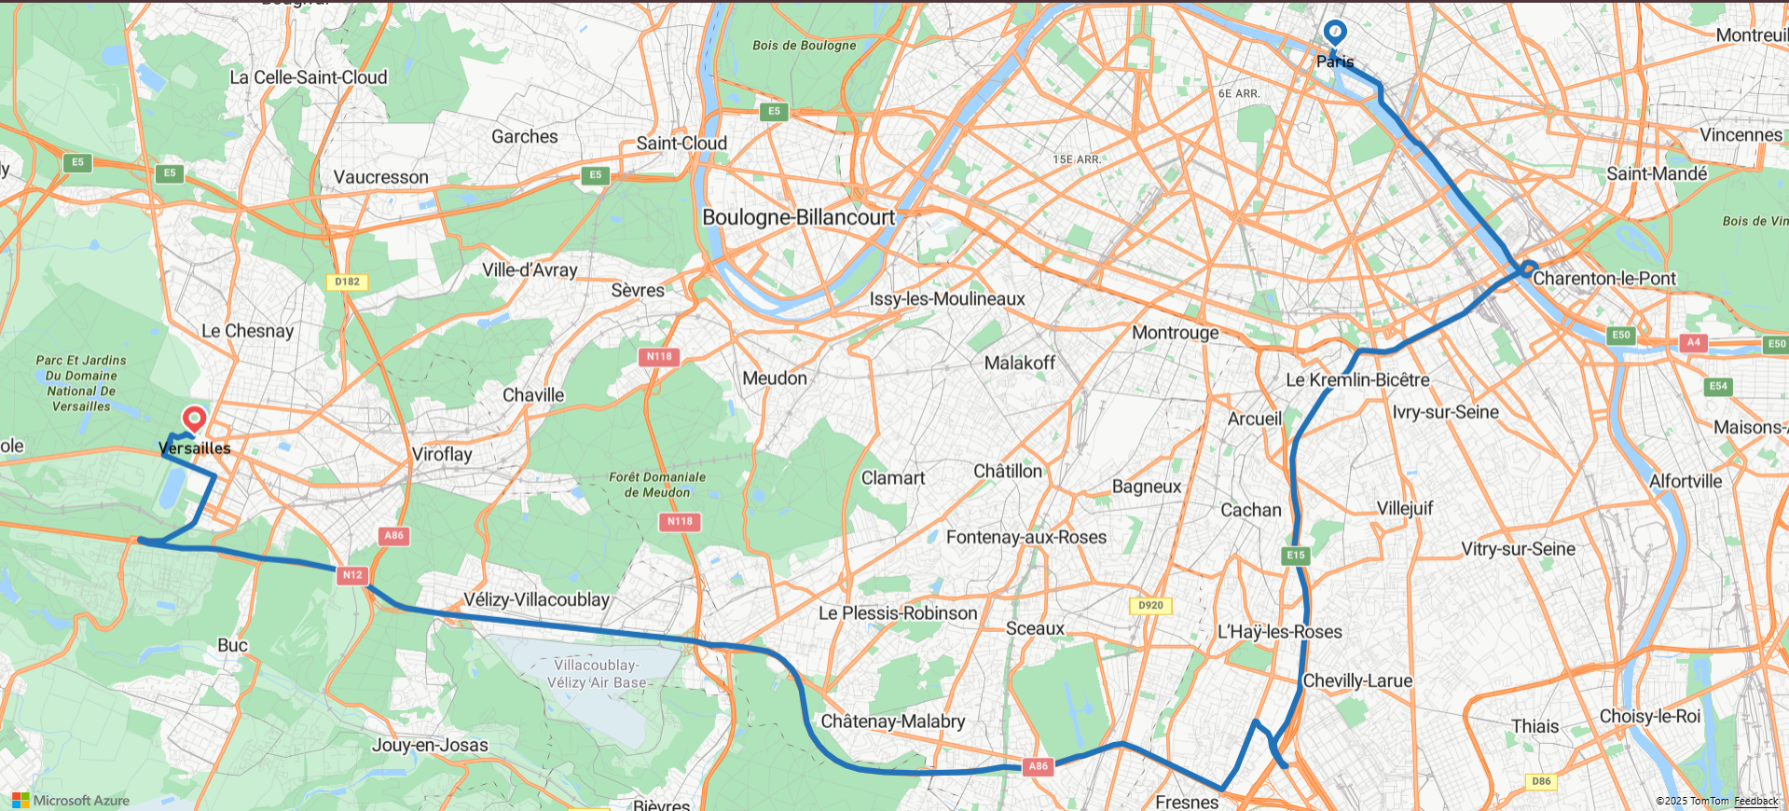

**Fig 5.1: Map showing route between Paris and Versailles**

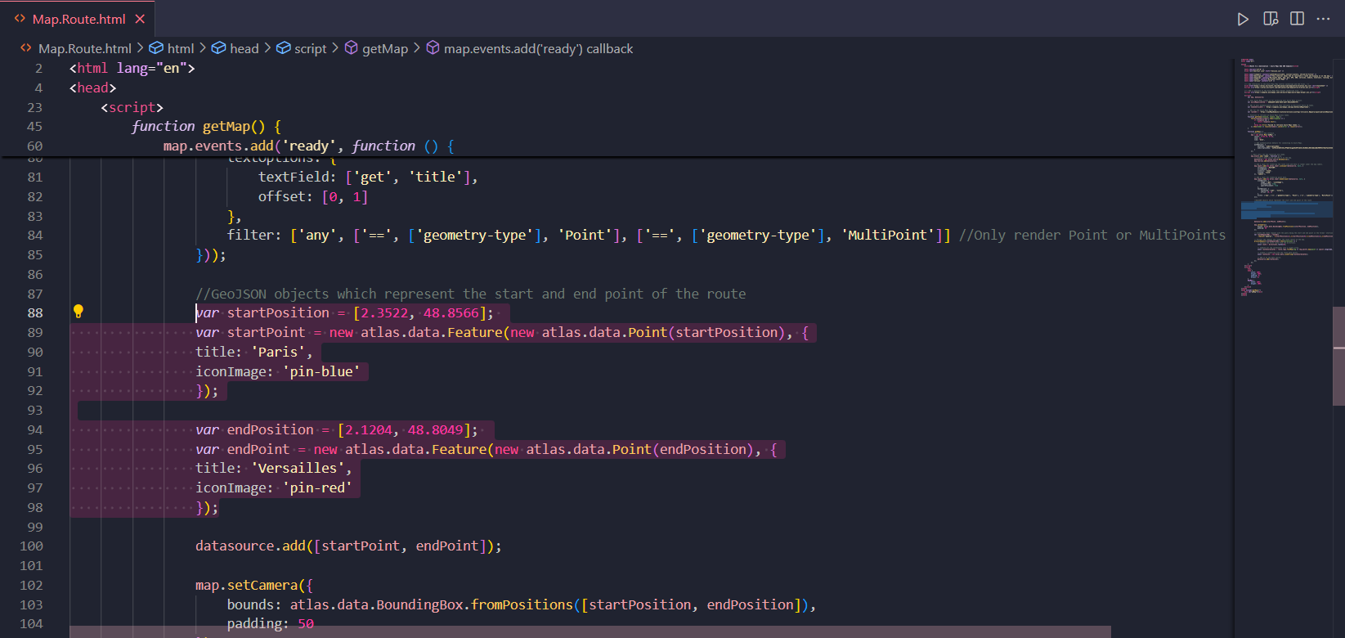

**Fig 5.2: Code snippet highlighting location coordinates**

What I learned how:

* Route geometry is returned as polylines
* To visualize those using the Map Control SDK
* Additional metadata (duration, distance) can be extracted and used in the UI

## 7.3 Truck vs Car Route Simulation

This was one of the most interesting parts. Using a new map configuration, I simulated logistics movement by requesting routes for both private cars and commercial trucks. The first version, between Lyon and Grenoble, showed both vehicles taking the same path. But in a second version between Nice and Castellane, I could see how Azure re-routes trucks differently — avoiding tunnels or roads that may have weight/height restrictions.

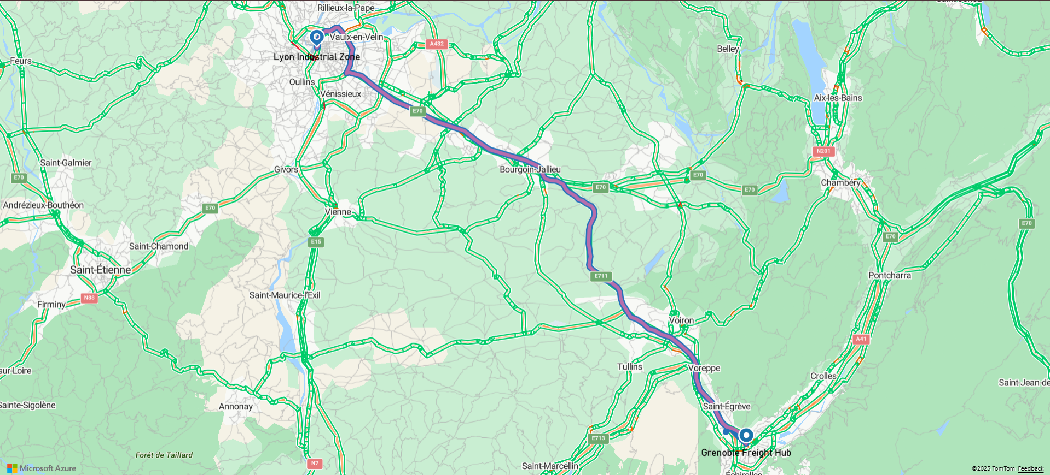

**Fig 5.3: Map showing private car and commercial truck route between Lyon and Grenoble**

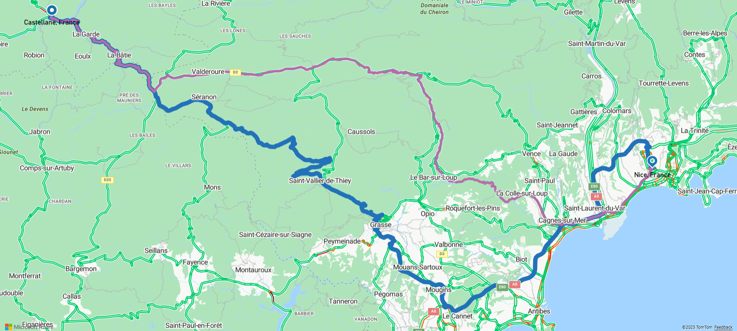

**Fig 5.4: Map showing private car and commercial truck route between Nice and Castellane**

This gave me real-world insight into:

* How truck-specific constraints affect route planning
* How Azure Maps automatically applies road restrictions
* Use of different colours/line widths to differentiate route types on a map

## 7.4 Custom Store Locator

Using dummy data for a coffee shop chain, I created a store locator that plotted store pins around Lyon. It could detect the user’s location using the browser and calculate the distance to the nearest outlet.

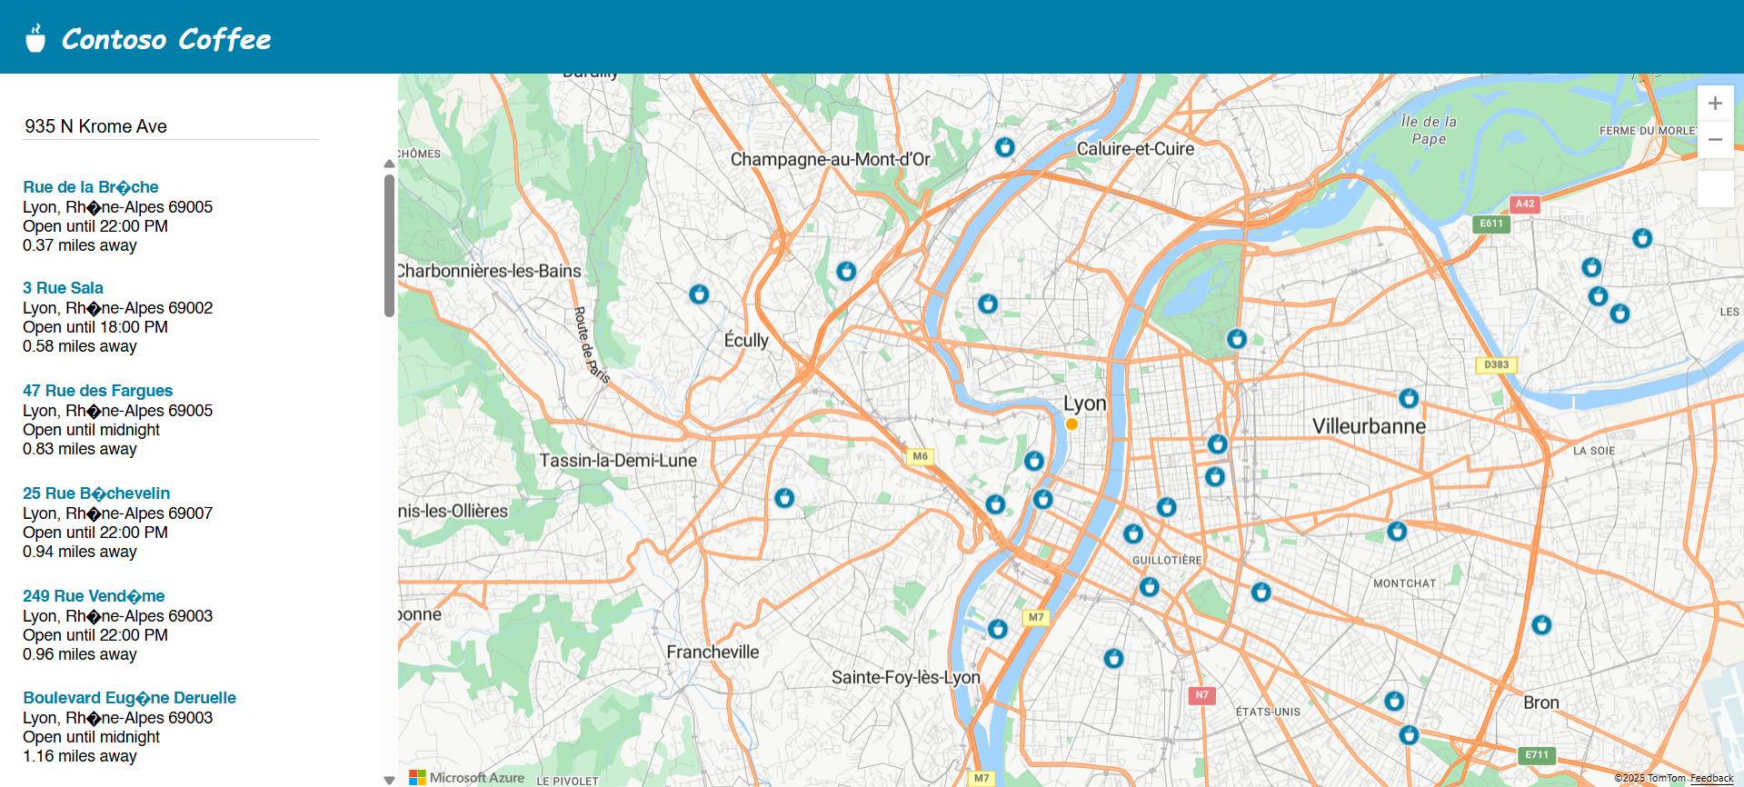

**Fig 5.5: Map showing nearby coffee branches of Consto Coffee**

Key outcomes:

* Handling user geolocation in the browser
* Loading location data from JSON/CSV
* Creating clickable custom pins with hover states

## 7.5 Sensor + Weather Data Visualization

The final Azure project moved outside the web stack. I used **Visual Studio Code** to overlay weather forecast data with mock turbine sensor readings. Azure Maps provided the weather forecast API, and I created matplotlib plots to compare wind speed and direction across different regions.

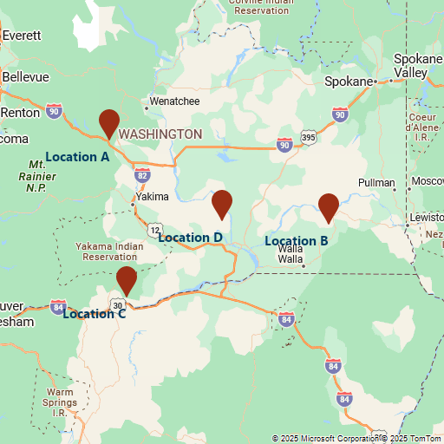

**Fig 5.6: Map showing 4 main locations**

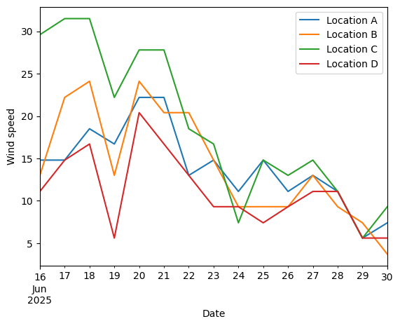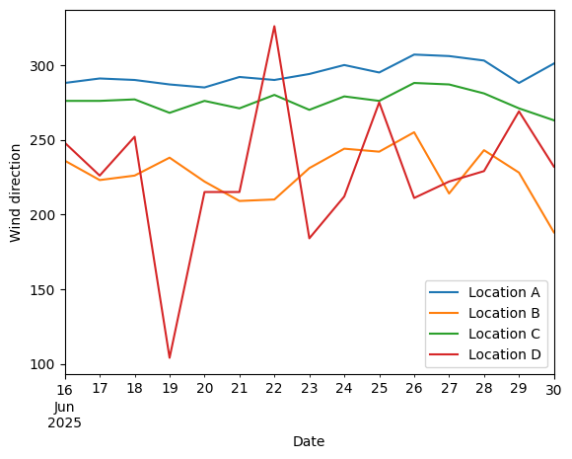

**Fig 5.7, 5.8: Graph displays wind speed and direction respectively**

This integration showed how:

* Python can be used with Azure Maps APIs
* Forecast and live sensor data can be visualized together
* Real-world applications like smart grids or renewable energy forecasting use cloud tools

Across all these exercises, I built more confidence working with REST APIs, interpreting JSON responses, and tying together location-based intelligence into visually meaningful results. These projects formed the foundation before I transitioned into more AI-driven tasks using Google Cloud.

# 8. Google Cloud Platform Projects

After exploring Azure Maps, I transitioned into working with **Google Cloud Platform (GCP)**, particularly its AI suite known as **Vertex AI**. My goal was to understand how large language models (LLMs) are integrated, prompted, and evaluated at scale. This part of the internship gave me hands-on exposure to prompt engineering, structured comparisons between model versions, and using model outputs in different formats.

## 8.1 Exploring Vertex AI Studio

Vertex AI Studio is the interactive environment where I ran most of my experiments with generative models. It allows developers to create prompts, submit them to different versions of the Gemini model family (here I’ve used **Gemini 2.5 Flash,** **Gemini 2.5 Pro** and **Gemini 2.0 Flash**), and compare outputs directly (Fig 7).

I started by submitting a simple prompt about planning a two-week itinerary for Japan and South Korea, then ran that same prompt through the three different Gemini models.

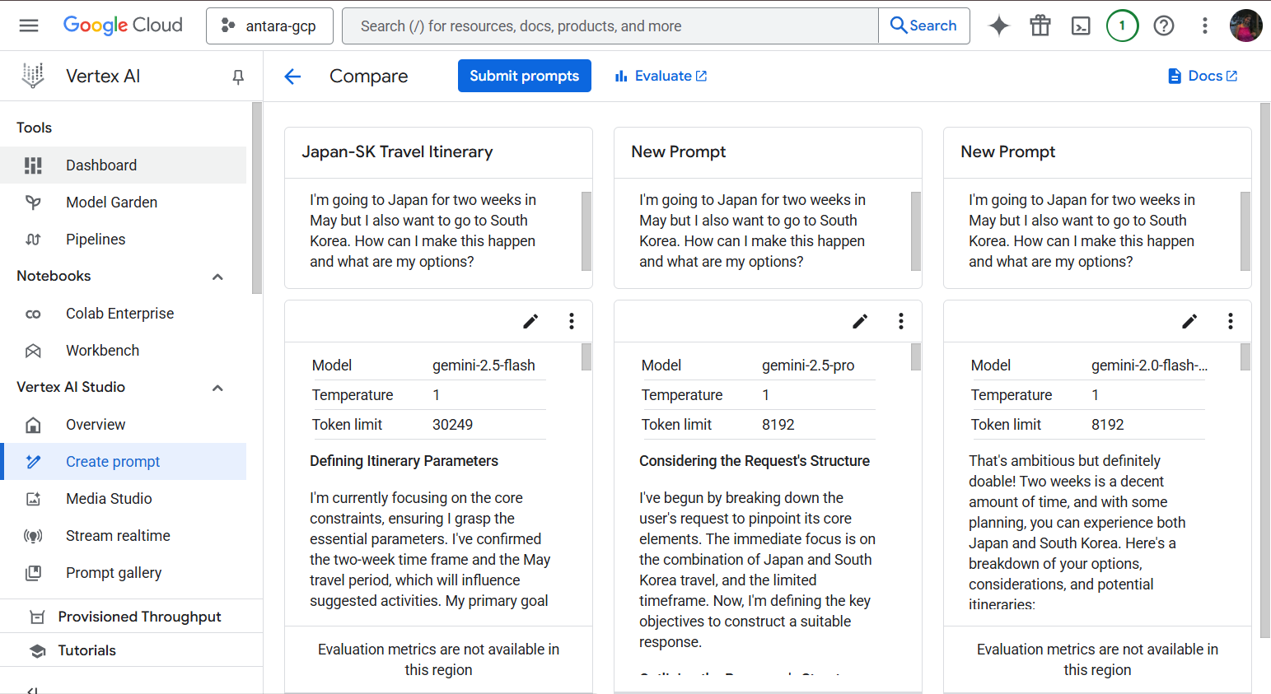

**Fig 6.0: Output variation in different Gemini models**

The outputs varied in structure, tone, and suggestion depth. This allowed me to:

* Evaluate differences in model reasoning
* Understand the impact of token limits and temperature settings
* Learn how to format prompts for clarity and consistency

## 8.2 Prompt Iteration and System Instructions

I experimented with system instructions to guide the model’s behaviour. For instance, I ran sentiment analysis prompts for shoe reviews using three different formats:

1. **Prompt 1**: Most basic question asking for sentiment. Focuses purely on stating the sentiment & providing concise justification without explicit requirements for the explanation’s depth or format

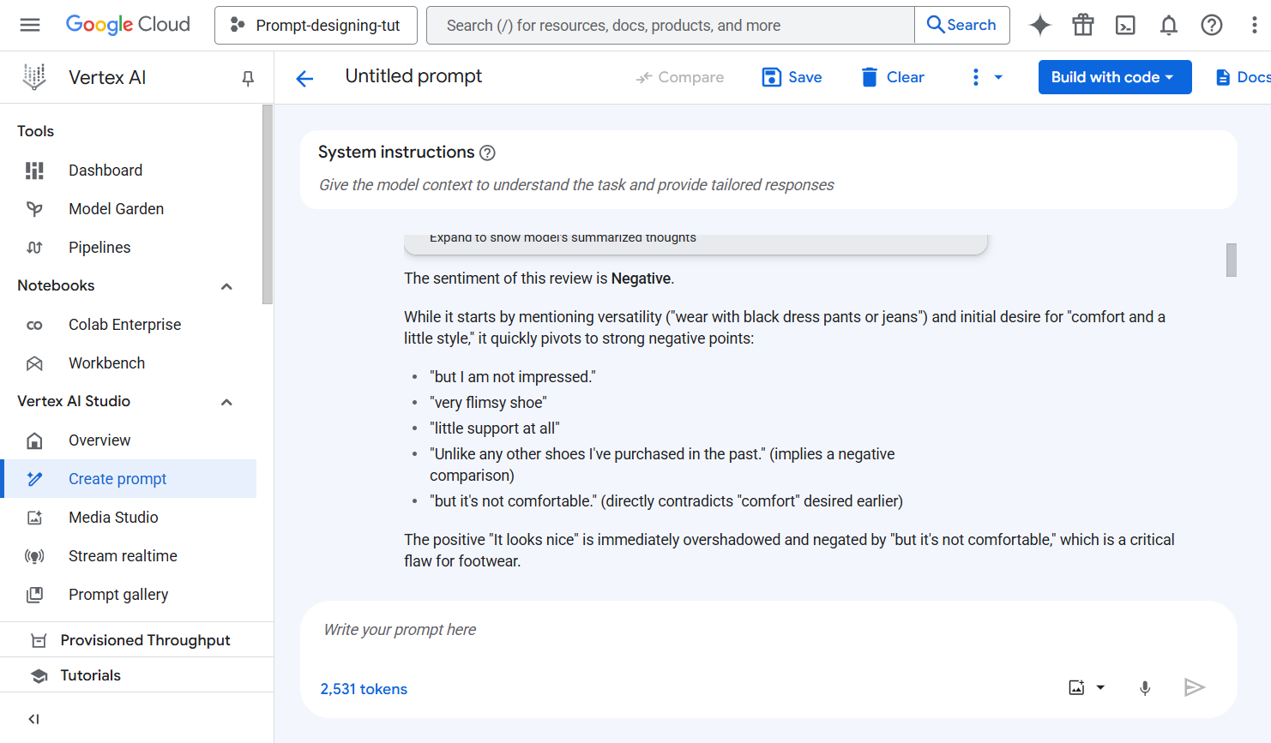

**Fig 6.1: Free-form output focusing purely on sentiment**

1. **Prompt 2**: Same question but with a explicitly asks for a detailed explanation of the reasoning and implies a need of greater justification, but still in free-form text format

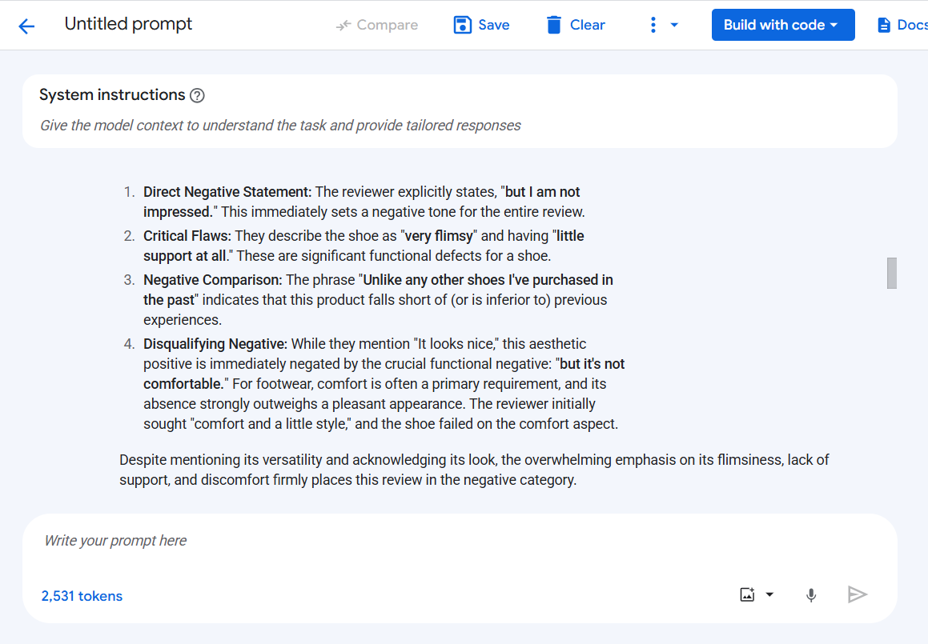

**Fig 6.2: Slightly more detailed output**

1. **Prompt 3**: The most constrained prompt. Other than detailed explanation it also requests a structured JSON output with defined fields (sentiment and explanation), making it machine-readable & suitable for programmatic integration.

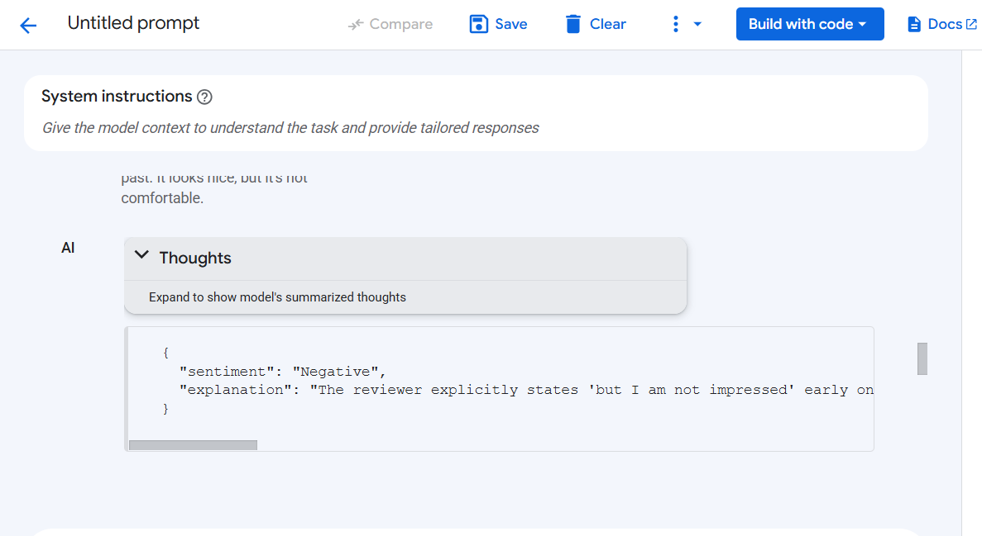

**Fig 6.3: Structured JSON output**

By comparing the results, I noticed how model responses became progressively more structured, logical, and usable for real applications. Especially with Prompt 3, the JSON output made it clear how LLMs can plug into pipelines that need machine-readable formats.

One particularly interesting part was evaluating the sentiment of a product review that initially seemed neutral but was quite negative. The model identified key reasons such as lack of comfort and poor design support, even though the review started with a positive tone. I ran multiple variants of this prompt, changed and studied how explanations changed in each version. This helped me understand:

* Prompt clarity affects reasoning depth
* Output format can be tailored to suit downstream use cases
* Model bias and inconsistency must be handled with careful design

## 8.3 Model Evaluation Using Vertex AI

In the final leg of this module, I studied **model evaluation techniques** using Vertex AI’s Evaluate feature. I learned that even the best models face challenges like:

1. **Overfitting**: Performing well on training data but poorly on new data
2. **Data Shift**: Real-world data changing over time
3. **Metric Mismatch**: Relying on single metrics like accuracy, which may overlook other crucial factors like fairness or recall
4. **Interpretability**: Difficulty understanding deep models like neural nets

To combat these, Vertex AI provides structured evaluation methods using batch predictions and comparison against labelled ground truth. The process involved:

* Running a batch prediction job
* Uploading a labelled test dataset
* Reviewing evaluation metrics such as precision, recall, AUC, and F1-score
* Analysing model drift and retraining if performance degrades

I also explored **model comparison** tools which visualize performance across different configurations and input slices.

## 8.4 Tuning Methods

Lastly, I briefly explored **model tuning options** in Vertex AI. The platform supports:

1. **Supervised Tuning**: Best suited for tasks like classification, entity recognition, and summarization
2. **RLHF (Reinforcement Learning with Human Feedback)**: Used for tasks requiring more nuanced language behaviour, such as summarization and creative writing

I didn’t perform a full tuning cycle due to limitations, but reading through the documentation and setup steps gave me a deeper appreciation of how production-grade AI models are refined post-training.

This part of my internship offered a mix of experimentation and theory. By combining prompt-based exploration with model evaluation tools, I gained a clearer picture of what it takes to manage and scale LLMs in a cloud setting. The Vertex AI interface made it approachable, but the underlying decisions around evaluation, fairness, and interpretability revealed the complexity of real-world AI deployment.

# 9. Coursera Learning

In addition to hands-on projects, I enrolled in few Coursera courses that gave me a more structured and theoretical foundation for what I was building in Azure and GCP. These courses helped me understand the broader lifecycle of machine learning operations including not just training models, but also deploying, evaluating, and monitoring them in production environments.

## 9.1 Operationalizing LLMOps with Azure

This course introduced me to the emerging field of Large Language Model Operations (LLMOps), which deals with managing the lifecycle of large language models in real-world applications. Unlike traditional MLOps, LLMOps involves unique challenges like unpredictable outputs, heavy token usage, and sensitivity to input phrasing. Through a mix of video lectures and hands-on labs, I learned how to design, deploy, evaluate, and optimize LLM-driven services on Microsoft Azure.

**Module 1: Introduction to LLMOps**

This opening module set the tone by explaining what makes LLMOps distinct from classical machine learning operations. It highlighted the challenges of deploying LLMs at scale and covered how prompt design and evaluation become part of the operational workflow. The key idea was thatLLMs don’t learn from new data after training. Prompts must adapt instead.

**Module 2: Prompt Engineering and Output Control**

Here, I explored how model behaviour can be tuned using well-structured prompts and control parameters. Labs involved using Azure OpenAI to run zero-shot, one-shot, and few-shot examples while observing how temperature, max tokens, and frequency penalties affect responses.

**What I practiced:**

* Creating dynamic prompts with different tones
* Using system messages to guide LLM behaviour
* Testing repeatability and randomness

**Module 3: Endpoint Deployment and Security**

This was the most technical module. It showed how to create and manage secure API endpoints for LLM access. Topics included:

* Deployment using Azure’s RESTful endpoint services
* Managing access via keys and role-based controls
* Handling latency and scaling for concurrent users

I also learned to connect frontend apps to deployed LLMs using POST requests and JSON payloads.

**Module 4: Cost Management and Token Monitoring**

Since most LLM services are priced by token consumption, the course introduced budgeting practices and tools to control usage. I explored:

* Designing shorter prompts without losing clarity
* Trimming API responses using stop sequences and max tokens

This helped me think critically about prompt efficiency, not just effectiveness.

**Module 5: Logging, Testing, and Continuous Evaluation**

This module emphasized that LLM outputs can’t just be tested once. They require iteration, user feedback, and performance tracking. The course covered:

* A/B testing of prompts across user queries
* Logging responses for bias and failure analysis
* Tracking prompt success rates using structured output formats

Azure also provides hooks to export logs to monitoring services, which can be useful in production apps.

What stood out to me most in this course was the idea that LLMs are not static. Their performance depends on how clearly and cleverly you write prompts. And that even once deployed, an LLM-based system must be treated as a live, evolving tool- one that needs feedback, testing, and iteration.

This mindset shaped how I later approached work on Google Cloud’s Vertex AI and prompt testing with Gemini models.

## 9.2 Machine Learning Operations with Vertex AI: Model Evaluation

This Coursera course offered by Google Cloud was a crucial supplement to my hands-on work with Vertex AI. It explored the challenges of evaluating models in real-world environments and provided a comprehensive framework for model monitoring, fairness analysis, and continuous performance assessment. While the course is still ongoing as I complete the final labs, the content has already significantly deepened my understanding of operationalizing AI responsibly.

**Module 1: Understanding Evaluation Challenges**

The course began by addressing the most common pitfalls in model evaluation that engineers face post-deployment:

* Overfitting: When models perform well on training data but fail to generalize to unseen examples.
* Data Shift and Concept Drift: When real-world data gradually changes over time, degrading model performance.
* Unrepresentative Training Data: When certain data classes or features are underrepresented, leading to poor performance on edge cases.
* Metric Mismatch: When evaluation relies too heavily on a single metric like accuracy, ignoring other dimensions such as recall, F1-score, or class imbalance.
* Interpretability Issues: Especially with deep learning models, outputs can be hard to explain to stakeholders.
* Bias and Fairness: Biased training data can lead to real-world discrimination or exclusion, especially in critical domains like finance, recruitment, and healthcare.

These challenges laid the groundwork for why model evaluation must go beyond static metrics and into live monitoring and slicing across multiple dimensions.

**Module 2: Strategies to Mitigate Evaluation Challenges**

The course introduced a wide set of mitigation practices, including:

* Metric Diversity: Using combinations of metrics like AUC-ROC, precision, recall, log loss, and confusion matrices to get a fuller picture.
* Cross-Validation and Stratified Sampling: To ensure models aren’t biased by data splits.
* Regularization, Dropout, Early Stopping: For avoiding overfitting during training.
* Explainability Tools: Methods like LIME, SHAP, and feature importance to help audit black-box models.
* Fairness Evaluation: Applying fairness metrics and disaggregated evaluation by data slices (age, gender, region, etc.).

This section of the course helped me move beyond thinking of model evaluation as a one-time step and instead see it as a full monitoring system.

**Module 3: Evaluation Workflow in Vertex AI**

Vertex AI offers a clear, replicable evaluation workflow:

* Train your model: Either with AutoML or custom scripts.
* Run batch prediction: On validation/test datasets.
* Prepare ground truth: Clean, abelled reference data.
* Start evaluation: Vertex compares predictions to ground truth automatically.
* Analyze metrics: Across the dataset and user-defined slices.
* Iterate: Refine your model and rerun the evaluation as needed.

I learned that this workflow supports a full lifecycle, where models can be evaluated multiple times across updates and new datasets.

**Module 4: Visualization and Continuous Monitoring**

One of the course’s most valuable components was how it used Vertex AI to support:

* Side-by-side model comparison
* Metric breakdown by feature slices
* Performance visualization over time
* Alerts for drift detection and retraining triggers

These tools help teams decide whether a model is suitable for production or if it needs improvement before deployment or retraining after being in production, thus concluding the course.

This course changed how I view ML model development. It’s not just about getting a high score on a validation set. It’s about maintaining performance, understanding decisions, and preventing harm as data evolves.

Model evaluation is not a step. It’s a cycle. And with tools like Vertex AI, it becomes possible to run this cycle efficiently and transparently, even at production scale.

# 10. Comparative Study: Azure vs GCP vs AWS

Working with both Microsoft Azure and Google Cloud Platform (GCP) during my internship allowed me to compare how these platforms differ when performing similar tasks, especially in the realm of AI/ML workflows and cloud resource management. To provide a more comprehensive view of the cloud ecosystem, I’ve also included a general comparison with **Amazon Web Services (AWS)** which is the third major player in the cloud industry - based on widely available documentation and common practices (Table 1).

|  |  |  |  |
| --- | --- | --- | --- |
| Feature/Area | Microsoft Azure | Google Cloud Platform (GCP) | Amazon Web Services (AWS) |
| Prompt Execution | Prompt engineering through REST APIs, mostly manual | Built-in prompt designer, versioned side-by-side comparisons | SageMaker JumpStart offers limited GenAI prompt testing; third-party models can be deployed |
| LLM Integration | LLMOps integrated into Azure ML workflows, prompt templates available | Gemini models accessible within Vertex AI Studio, live testing supported | Amazon Bedrock provides access to multiple foundation models (Anthropic, Cohere, etc.) |
| Explainability | Limited built-in support: third-party tools like SHAP needed externally | Built-in visualization, feature importance, SHAP integration available | Amazon SageMaker Clarify supports built-in bias detection and explainability metrics |
| Model Evaluation | Good traditional metrics; lacks region-based prompt evaluation tools | Advanced model evaluation options, compare/evaluate side-by-side prompts with metrics | Evaluation requires custom setup or external tools; less seamless than GCP’s built-in tools |
| AutoML | Transparent training process, logs available, wider range of metrics | Quick setup, strong integration, less manual tuning required | AutoML through SageMaker Autopilot; supports full pipeline automation but more setup required |
| Notebook Integration | Azure Notebooks or external Jupyter integration needed | Native support in Workbench and Colab Enterprise with seamless data access | SageMaker Studio provides Jupyter-based IDE with native cloud integration |
| Learning Resources | Coursera content well-organized but broad | Vertex AI course offers niche, practical use cases for GenAI | AWS Skill Builder, Coursera, and Udemy cover AWS ML stack thoroughly but less GenAI-focused |
| Monitoring and CI/CD | Supports pipelines with Azure ML Pipelines and GitHub Actions | Cloud Build, Model Monitoring, and automatic drift detection built-in | CI/CD supported via CodePipeline, SageMaker Pipelines, and CloudWatch for drift monitoring |

**Table 1: Comparison table**

**In summary**, each platform brings distinct strengths to the table depending on project goals and developer needs. **Microsoft Azure** offers greater control, structured workflows, and robust enterprise-grade integrations, making it ideal for traditional ML pipelines and regulated deployments. **Google Cloud Platform (GCP)** excels in generative AI experimentation, fast prototyping, and intuitive tools like Vertex AI Studio for side-by-side model comparison and evaluation. **Amazon Web Services (AWS)**, with its broad model access via Bedrock and mature MLOps through SageMaker, is highly customizable but requires more setup for GenAI tasks. Ultimately, the right platform depends on context — large organizations with structured processes may prefer Azure, rapid iteration teams focused on prompt engineering may lean toward GCP, and flexible builders seeking access to diverse models and custom workflows may benefit from AWS.

# 11. Challenges Faced

Despite the flexibility of cloud platforms, I encountered several challenges during the internship that helped shape my learning process:

* + **Vertex AI Regions Limitation:** Vertex AI's model evaluation and comparison metrics were limited based on regions. This meant that despite running prompt comparisons, detailed evaluation metrics were unavailable unless the right location was chosen.
  + **Prompt Behaviour Variability:** Even with identical prompts, model outputs across Gemini versions could vary significantly. This made result interpretation difficult unless carefully structured metrics were defined.
  + **Conceptual Drift:** When using AutoML-trained models, I noticed performance drops when input datasets shifted, underlining the importance of using validation data that represents real-world distributions.
  + **Course Structure Confusion:** Initially, the Coursera modules on LLMOps and Vertex AI felt overwhelming. There were overlapping concepts between tools, and it took some effort to differentiate what Azure’s tooling did vs what GCP’s Vertex AI offered.

# 12. Industry Challenges and Opportunities

Modern AI-driven cloud platforms promise to transform operations across sectors, but several critical challenges still hinder their full-scale adoption.

## 12.1 Key Industry Challenges

* **Data Overload without Insight:** Although organizations collect huge amounts of data, many struggle to derive actionable insights due to inconsistencies and lack of real-time interpretation.
* **Fragmented Ecosystems:** Various systems like ERP, GIS, or OMS often fail to integrate seamlessly, leading to disconnected datasets that slow down decision-making.
* **Manual or Reactive Maintenance:** In industries reliant on equipment, maintenance is still often reactive. A lack of proactive, predictive tools results in unplanned downtimes.
* **Poor ROI from AI Systems:** Many companies invest in modern AI platforms but fail to utilize advanced features, sticking to legacy workflows and limiting the ROI.
* **Underused Functions:** Without contextual intelligence or automation, even well-designed systems remain underleveraged.

## 12.2 Emerging Opportunities

* **Connected Assets and IoT Integration:** As machines and tools become smarter, cloud systems can gather live data to assess health, predict failure, and prioritize workloads.
* **AI-based Visual Inspection and Assistants:** Tools such as computer vision defect detectors or voice-based digital assistants can automate frontline tasks.
* **Dashboards and Decision Support Systems:** Real-time dashboards offer a unified view of metrics, risks, and system alerts, greatly helping supervisors and analysts.
* **ML-Powered Scheduling and Prioritization:** By learning from historical and contextual data, AI models can schedule work orders by urgency and impact.

These challenges and opportunities shaped how I explored tools like Vertex AI and Azure ML in real-world scenarios. The experience underscored that technical capability must always be paired with thoughtful integration and human understanding.

## 12.3 Latest Trends in AI & Cloud Deployment

The cloud and AI ecosystem continues to evolve rapidly, with major platforms like Azure, GCP, and AWS integrating newer capabilities that are reshaping how businesses build and deploy intelligent applications. Some key trends observed in 2024–2025 include:

* **LLMOps and PromptOps**: Beyond traditional MLOps, the industry is moving toward **LLMOps** — a specialized branch for managing large language models in production. GCP and Azure now support structured prompt templates, multi-version comparisons, and feedback-based prompt tuning pipelines.
* **Multimodal Models**: With the rise of tools like Gemini 1.5 and GPT-4o, cloud platforms are investing in multimodal AI — capable of handling text, image, audio, and video simultaneously. This is leading to broader applications in areas like virtual assistants, customer service, and logistics.
* **Retrieval-Augmented Generation (RAG) at Scale**: Organizations are increasingly implementing RAG systems to combine LLM reasoning with internal knowledge bases. Vertex AI and AWS Bedrock now offer out-of-the-box connectors for vector databases like **Pinecone**, **Chroma**, and **FAISS**.
* **Generative AI Agents**: Cloud-native agent builders now support **autonomous multi-step task planning**, often integrated into business workflows. GCP’s **Vertex Agent Builder**, Azure’s **Copilot Studio**, and AWS’s **PartyRock** are examples.
* **Green AI and Cost Optimization**: With growing concern around carbon usage and cost efficiency, tools for **token monitoring, resource-aware deployment**, and **serverless inference** (e.g., GCP’s PaLM Flash models or Azure OpenAI with auto-scaling) are becoming more critical.

## 12.4 Use Cases

|  |  |  |  |  |
| --- | --- | --- | --- | --- |
| Company | Cloud Platform | Use Case | Technologies Involved | Source |
| Deutsche Bank | Google Cloud | Automated generation of financial and compliance summaries | Vertex AI, Prompt Engineering, Model Evaluation | Google Cloud Blog |
| Mercedes-Benz | Microsoft Azure | Conversational in-car assistant and customer service AI | Azure OpenAI, GPT Models, Prompt Templates | Microsoft Customer Stories (Mercedes‑Benz & Azure OpenAI) |
| UPS | Google Cloud | Predictive maintenance using IoT data and ML model scoring | Vertex AI, anomaly detection, IoT integration | Google Cloud customer spotlight – UPS |
| Canva | Amazon AWS | Personalized content suggestions and design completions | Amazon Bedrock, RAG Techniques, Foundation Models | AWS customers site – Canva & Bedrock |
| Spotify | Google Cloud | AI-powered music recommendations and user playlist generation | BigQuery, Pub/Sub, LLM-based metadata enrichment | Google Cloud customer page – Spotify |
| BMW Group | Amazon AWS | Cloud assistant (ICCA) for DevOps optimization using GenAI | Amazon Bedrock agents (ReAct), root-cause analysis, LLM | AWS blog on BMW GenAI assistant |

**Table 2: Real World Use Cases of GenAI**

# 13. Key Learnings

This internship helped deepen my understanding of both cloud infrastructure and machine learning operations. Here are some of the key takeaways:

* Learned how to work with Azure Maps APIs and integrate real-world geospatial data into notebooks.
* Understood how to deploy prompts across multiple Gemini models and interpret their behaviour.
* Gained insight into common evaluation challenges like overfitting, concept drift, and fairness concerns.
* Practiced comparing prompt output with structured formatting like JSON and sentiment analysis with reasoning.
* Learned about GCP’s concept of continuous evaluation and the workflow for maintaining deployed models.

# 14. Future Scope

Cloud AI is an area that’s only going to grow more important. This internship has laid a strong foundation, but there are several directions I plan to explore further:

* Dive deeper into model monitoring and anomaly detection pipelines post-deployment.
* Explore CI/CD workflows for ML models using Azure ML Pipelines and GCP Cloud Build.
* Experiment with tuning LLMs using reinforcement learning (RLHF) in GCP.
* Build mini tools that utilize Vertex AI’s APIs for real-world applications, such as summarizers or classifiers.

# 15. Conclusion

This internship allowed me to explore and apply cloud technologies in a practical and deeply engaging way. From using geospatial APIs and data overlays to deploying generative AI models and analysing their behaviour, the learning experience has been both broad and technical.

The contrast between Azure and GCP helped me appreciate how different providers approach the same problems with different philosophies and tooling. GCP gave me a glimpse into the evolving field of generative AI operations and the future of model evaluation.

Above all, this internship fostered my confidence to independently pick up new tools, explore documentation, and apply learning to real scenarios. I walk away from this experience with a clearer understanding of what it means to build, evaluate, and improve intelligent systems in the cloud.

# 16. Appendix

## Appendix A: Coursera Certifications

A.1 – Operationalizing LLMs on Azure  
Coursera – Completed in June 2025

**Access Link:** <https://coursera.org/share/bffba40d67a7b5c341cac0cb6c51ae96>

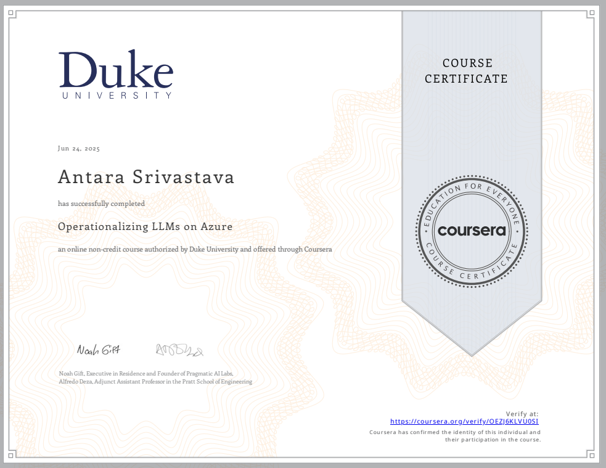

A.2 – Machine Learning Operations with Vertex AI: Model Evaluation  
Coursera – Completed in July 2025

**Access Link:** <https://coursera.org/share/d6efe50152a13bfda2a6882f0e0d06af>

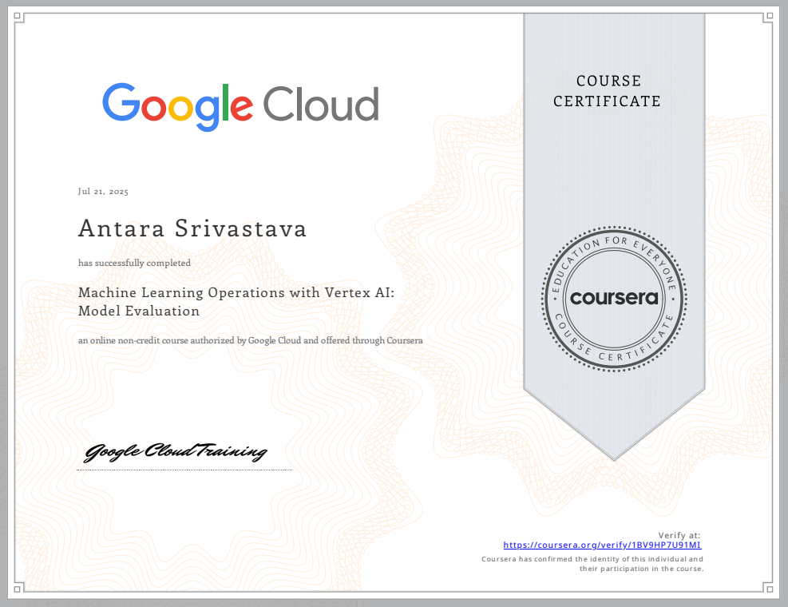

## Appendix B: Code Snippets

B.1 – Record Store centre

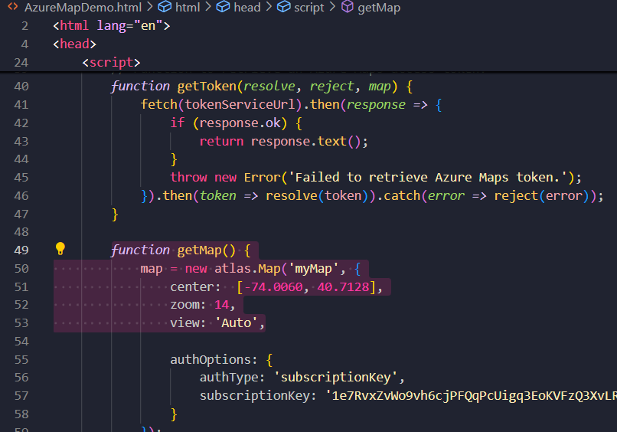

B.2 – Truck Map Route Locations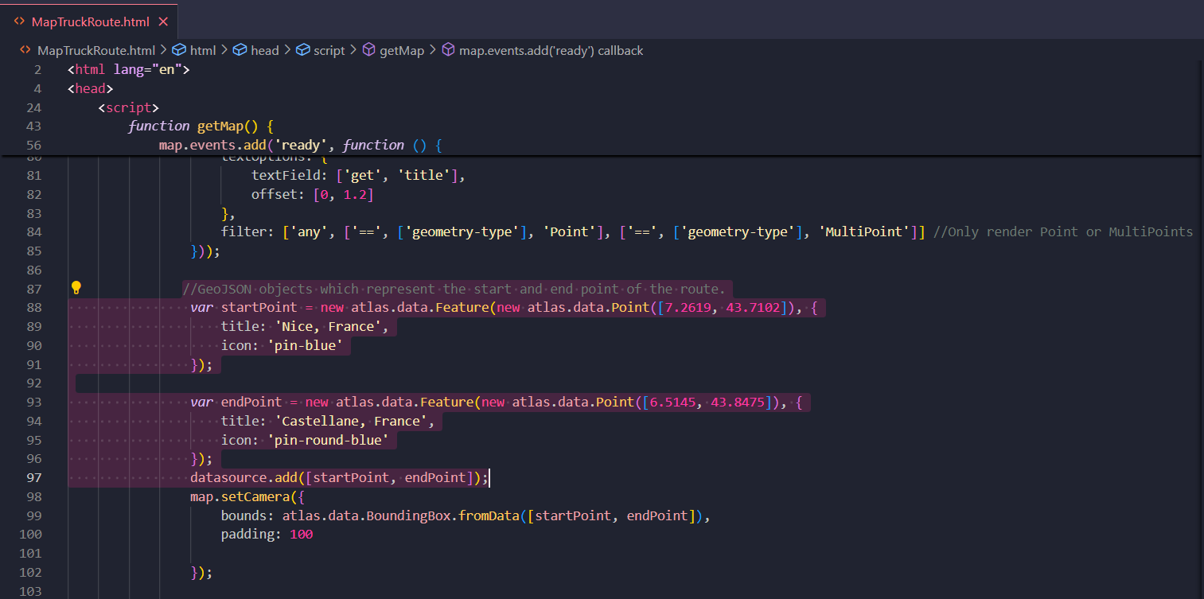

B.3 – Weather Dataset

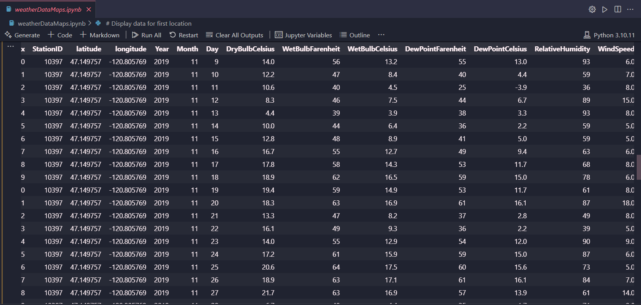

# 17. Bibliography

1. Microsoft Azure Documentation: <https://learn.microsoft.com/en-us/azure/>
2. Azure Maps REST API Docs: <https://learn.microsoft.com/en-us/rest/api/maps/>
3. Google Cloud Platform Documentation: <https://cloud.google.com/docs>
4. Vertex AI Overview: <https://cloud.google.com/vertex-ai/docs/overview>
5. Generative AI on GCP: <https://cloud.google.com/vertex-ai/generative-ai/docs>
6. Gemini API Documentation: <https://cloud.google.com/vertex-ai/generative-ai/docs/model-reference/gemini>
7. Coursera – LLMOps with Azure: <https://www.coursera.org/learn/llmops-azure>
8. Coursera – Model Evaluation with Vertex AI: <https://www.coursera.org/learn/machine-learning-operations-with-vertex-ai-model-evaluation>
9. Google Cloud AI and ML Products: <https://cloud.google.com/products/ai>
10. Introduction to Vertex AI: <https://www.mindinventory.com/blog/what-is-vertex-ai/>
11. Google Cloud AI Studio: <https://cloud.google.com/vertex-ai/studio>
12. Vertex AI Model Evaluation: <https://cloud.google.com/vertex-ai/docs/evaluation/overview>
13. Prompt Engineering Patterns – Google AI: <https://cloud.google.com/vertex-ai/docs/generative-ai/text/prompt-engineering>
14. Prompt Engineering Techniques: <https://medium.com/the-modern-scientist/prompt-engineering-classification-of-techniques-and-prompt-tuning-6d4247b9b64c>
15. Diagrams made via: <https://app.diagrams.net/>
16. Google Cloud. (2025, February 12). How betting on the cloud set the stage for Gen AI at Deutsche Bank. Google Cloud Blog. <https://blog.google/products/google-cloud/deutsche-bank-google-cloud-partner/>
17. Microsoft. (2023, June 15). Mercedes‑Benz enhances drivers’ experience with Azure OpenAI Service. Microsoft Azure Blog. <https://azure.microsoft.com/en-us/blog/mercedes-benz-enhances-drivers-experience-with-azure-openai-service/>
18. Google Cloud. (2024, November 26). Google’s Gemini AI assistant now works with Spotify. The Verge. <https://www.theverge.com/2024/11/26/24306815/google-gemini-spotify-extension-rollout>
19. Amazon Web Services. (2023, December). BMW Group develops a GenAI assistant to accelerate cloud infrastructure optimization. AWS Blog. <https://aws.amazon.com/blogs/industries/bmw-group-develops-a-genai-assistant-to-accelerate-infrastructure-optimization-on-aws/>
20. Amazon Web Services. (2024). Genpact drives operational efficiencies using generative AI. AWS Case Study. <https://aws.amazon.com/solutions/case-studies/genpact-case-study-generative-ai/>
21. Amazon Web Services. (2024). Building a generative AI contact centre for DoorDash using Amazon Bedrock. AWS Case Study. <https://aws.amazon.com/solutions/case-studies/doordash-bedrock-case-study/>
22. Google Cloud. (2025). 601 real-world gen AI use cases from the world's leading organizations. Google Cloud Customer Story. <https://cloud.google.com/transform/101-real-world-generative-ai-use-cases-from-industry-leaders>